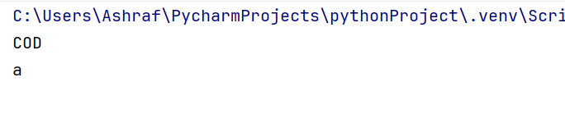
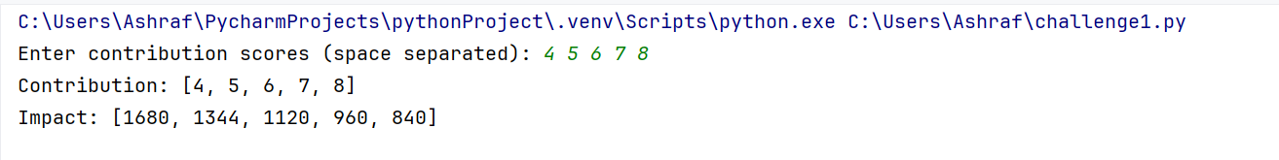
ALL OUTPUTS ARE IN SEQUENCE

